JSP
JSP stands for java server pages and it is use to develop web based applications.
- Generally we place all the JSP programs inside project folder. Every JSP program ends with an extension “.JSP “. We no need to configure JSP as part of web.xml file. We can send the request to the JSP’s directly from the browser.
Ex: http://localhost:8000/webapp/one.jsp
- There are so many advantages are available with JSP’s when compared with servlet. The following are some of the advantages of JSP’s when compared with servlets.
  - JSP’s improve the productivity of the developer (we can develop the JSP projects quickly when compared with servlets).
  - We can develop JSP’s without the package of java.
  - By using JSP’s we can sprat out business logic and presentation logic.
- When we deploy the project and client has sent to request to JSP the server has converted JSP program into corresponding servlet.
- An Apache guy has released HttpServer. This server can process HTML pages, images and JavaScript. This server can’t run servlet’s and JSP’s.
*What is a Servlet Container?
Servlet container is a program which provides the implementation of Servlet-API. It is the responsibility of Servlet Container to create Servlet object and call the life cycle methods of servlet.
*What is JSP container?
A JSP container is a program which provides the implementation of JSP-API. It is the responsibility of JSP container to run JSP programs. A Tomcat Server is a collection of HttpServer, Servlet Container and JSP container.
HTTP Server
Servlet Container
JSP Container

// Tomcat Server (web server)

Today’s server are aggregated into two ways. They are:
- Web Servers
- Application Servers
Most of the web servers run servlets and JSP’s. Application server run servelts and JSP’s as well as they can run EJB application also.
HTTP Server
Servlet Container
JSP Container
EJB Container
Directory Server
Security Prelims

Web logic Server Application Server
Tomcat is called as Web Server, Web logic, Web Sphere, JBoss are called as Application Servers.
An application server provides the complete implementation to JEE.API. Where as web servers can provide the partial implementation of JEE.API.
When we develop the JSP programs it is the responsibility of JSP container to convert JSP compiler to convert to run the JSP programs. The following steps will be carried out when a client send a request to server.
One.jsp

One.jsp
JSPC
/one.jsp
Servlet code
Client
javac
Server
Servlet byte codes
//one.jsp.class
The server will carry out all the above the steps when the client has sent the request to the JSP for the 1st time. When the client has sent the request 2nd time directly server execute the servlet object of the corresponding JSP.
Sun micro systems have inherited so many features of JSP programming language and develop JSP applications. Theoretically speaks we can develop JSP applications without writing java class.
According to the discussion as of new we have assented that we can develop the projects quickly and deliver to the customer easily based on JSP’s. No doubt servlets gives setter performance when compared with JSP’s.
Even though servlet’s give better performance when compared with JSP’s. We can’t measure the performance difference with human being eye. But when we consider the project cost we had a huge difference between servlet’s and JSP’s.
In most of the projects we use both servlets and JSP’s. If you want to execute huge amount to business logic we go with servlets. In the entire remaining scenario’s we use JSP’s.
It is the responsibility of the server to call the JSP compiler when the client sends the request to JSP. We can call JSP compiler manually. Generally we do this work to understand the internal code of generated servlet.
Procedure to call web logic JSP compiler:
- Set the class path to multiple jar files by using “setDomainEnv.cmd” (JSPC program available inside web logic.jar).
- Use the following command to generate the servlet.
>java weblogic.jspc -keepgenerated one.jsp

To place the source code(.java file)
By default web-logic JSP compiler removes .java programs. To retail the .java programs we use an option –keepgenerated. The following are the rules of JSP compiler which are available in JSP specifications.
- Every JSP compiler must generate a servlet and place it in .java program. Because of the above rule different servers are following different naming conversions in writing the servlet name (.java file).
For Web-logic they are using the file name like –One.java
For Tomcat they are using One-jsp.java
- Every generated servlet must be place inside a package. Different servers used different package names. (org.apache.jsp).
- Every generated servlet must import 3 different packages.
  - import javax.servlet.*;
  - import javax.servlet.http.*;
  - import javax.servlet.jsp.*;
- According to JSP specification every JSP compiler has to develop their own servlet. In that servlet we must over write 2nd init() and 2nd service() method. 2nd service() method must be call JSPService() method.
The following is the internal code of Tomcat JSP compiler.
public abstract class HTTPJSPBase extends HTTPServlet{
public void init(){
public void service(HTTPServletRequest request, HTTPServletResponse response){
-JSPService(request, response);
}
abstract public void –JSPService(HTTPServletRequest request, HTTPServletResponse response);
}
- When the JSP compilers develop a Servlet for the corresponding JSP we must declare the class as final.
- According to JSP specifications the parameters of –JSPService() method must be request and response only.
The following is the generated code of Tomcat JSP compiler.
package org.apache.jsp;
import javax.servlet.*;
import javax.servlet.http.*;
import javax.servlet.jsp.*;
public final class One_JSP extends HttpJspBase{
public void –JspService(HttpServletRequest request, HttpServletResponse response){
// standard local variables
}
}
When we observed the generated servlet of Tomcat and web-logic we have found extra methods. These methods are specific to the servers. These methods are not declare as part of JSP specification.
When the client send the request to server, server executes –JSPService() method.
In windows-7 OS if we are not able to see the generated servlet then we need to disable set of JSP elements. A JSP program contains set of JSP elements. The following are the elements of JSP. They are given below:
- Template Text
- Script let
- JSP Expressions
- JSP Declarations
- JSP Directives
- JSP Action Tags
- JSP Custom Tags
- EL Expressions(Expression Language)
*Template Text: This Element is used to send output to the client. We can write the Template TextElement.directly in the JSP without any special symbols.
Ex: First Line //TemplateText Line1
Second Line //TemplateText Line2
When we use Template Text the content will be placed inside out.Print() method. When we run the above JSP we got the following servlet.
public class Final one_jsp extends HttpJSPBase{
public void –JSPService(…….){
out.Println(“First Line”);
out.Println(“Second Line”);
}
}
The following is an example of sending a form to the client by using JSP’s.
<form>
User Name:<input type = “text” name = “uname”/><br>
Password:<input type = “Password” name = “pwd”/><br>
<input type = “submit” value = “Login”/>
</form> //One.jsp
Scriplets:
Scripts are used to write java code in JSP’s. The following is the syntax of Scriplet.
<% //start scriplet
Java code
%> //ending script
Ex:
<%
int a = 10;
System.out.println(a);
%> //One.JSP
When the JSP complier encounter a Scriplet directly placed inside –JSPService() method.
When we are using Scriplets in the JSP. We must follow all the rules in the java. If we don’t follow all the rules of java the JSP compiler will fail in converting .java program into .class file and JSP compiler displays Errors in Browser.
Welcome to JSP’s
<%
int a = 10;
System.out.println(a);
%>
JSP compiler follows set of rules in converting JSP program into corresponding Servlet program.
Implicit variables:
In JSP’s we can use some variables without we declaring it. The variables which can be used in JSP’s without declaring we call them as implicit variables or implicit objects. The following are of implicit variables available in the JSP.
- request
- response
- pageContext
- session
- application
- config
- out
- page
- Exception
Response: following is an example of using response object directly in the JSP.
<%
response.setContextType(“text/xml”);
out.println(“<student>”);
out.println(“<sno>|</sno>”);
out.println(“</student>”);
%>
We can send the error message directly to the client.
<%
O response.sendError(543,”abc”);
%>
Request:
Request implicit variable can be used directly in the JSP script without we declaring it.
request -----------------→ HttpServletRequest
<%
out.println(request.getMethod()+”<br>”);
out.println(request.getRequestURI()+”<br>”);
out.println(request.getProtocol()+”<br>”);
out.println(request.getHeader(“User Agent”)+”<br>”);
out.println(request.getHeader(“Accept-language”)+”<br>”);
%>
Req: Develop the following form based application by using JSP’s.
User Name:
Password:
The following details are you have Entered.
User Name: system
Password: MYS

Login

<%
String uname = request.getParameter(“uname”);
String pwd = request.getParameter(“pwd”);
%>
The following details are you have entered <br>
User Name: <%
out.println(uname);
%>
<br>
Password: <%
out.println(pwd);
%>
Out: We can out variable directly in the JSP scriplet without we declaring it.
out --→JSPWriter
JSPWriter is a class which is available in javax.servlet.jsp package.
In servlet we are used printWriter to send the output to the client. In JSP we use JSPWriter.
*What is the difference between PrintWriter and JSPWriter?
Every JSPWriter is associated with 8KB of internal Buffer. Where as PrintWriter doesn’t associated with any Buffer.
Ex: We can use both print and write() is an out variable.
<%
int a = 10;
int b = 20;
out.print(“A value is:”+a);
out.write(“B value is:”+b);
%>
XML:
xml is used to discuss the data while writing the xml file we must follow all the rules of xml. We can read the content of xml file if it is a valid xml file. If it is invalid xml file we can’t read the content from xml.
- If we want to develop a xml file we required either dtd file or xml sequence file. These documents contains all the tags which has to be used by xml developer.
- To resolve the xml problems in servlets sun micro systems has given a dtd file. This is used by all the server developers as well as servlet developers to write xml file.
- Sun micro systems has released servlets dfd document. All the servers have used this dfd and develop parser program. As developers we can follow the dfd file and create web.xml file.
- Because of security reasons we can configure JSP’s into web.xml file.
When ever we write any xml file based on dfd document we must specify in web.xml file.
<?_xml version = “1.0”?>
<! DocTYPE web-app PUBLIC “web.xml” “http://java.sun.com/dfd/web-app_2_3.dtd”>
<web-app>
</web-app> //web.xml
To resolve all the security related problems in JSP’s we can configure the JSP in web.xml file. The following is the configuration we use to configure a JSP into web.xml file.
<web-app>
<servlet>
<servlet-name>a</servlet-name>
<jsp-file>/WEB-INF/one.jsp</jst-file>
<servlet>
<servlet-mapping>
<servlet-name>a</servlet-name>
<url-pattern>/a</url-pattern>
<servlet-mapping>
</web-app>
Note: when we are writing <jsp-file> the path of the JSP must start with “/” .
- If we don’t want to allow any body to access the JSP directly recommended to place inside WEB-INF folder.
- We can use <load-on-startup> as part of web.xml file for a jsp.
<servlet>
<servlet-name>a</servlet-name>
<jsp-file>/WEB-INF/jsp/one.jsp</jsp-file>
<load-on-startup>4</load-on-startup>
</servlet>
- To a JSP when we use load-on-startup and when we deploy the project immediately server will convert jsp into corresponding servlet and the servlet.class will be loaded into JVM’s memory and it creates the servlet object.
Config: Config variable is belongs to servletConfig data type. By using servletConfig we can remove the hard coding.
Config----→ servletConfig
<%
String drv = config.getInitParameter(“drv”);
out.print(drv);
%>
servletConfig is an object used by servlet container to pass the information during initialization.
Once if we get the ServletConfig object, we can find the name of the servlet which is configured in web.xml file by using a method getServletName() method.
Ex:
<%
String name = config.getServletName();
out.println(name);
%>
As part of the url pattern if it end with .jsp, jsp compiler directly processes the jsp program.
Application: application -----→ ServletContext
- Application implicit variable can be used directly in the jsp.
- ServletContext object contains set of methods which are used to interact with ServletContainer. By using these methods we can find the information about ServletContainer.
- When ever sun micro system releases a new version of API. It is the responsibility of server vender to provide the implementation to the latest API. For example when servlet 2.5 is released Tomcat guys has provided the implementation and integrated it in Tomcat 6.0 the latest version of servlet API is 3.0 this version is integrated in Tomcat 7.0.
*What is the different between servlet-API 2.5 and servlet-API 3.0?
The servlet-API 3.0 supports processing annotations.
Session:
We can use session implicit variable directly in the jsp. Session implicit variable is holding Http Session object.
Session ----→ HttpSession
Page:
We can use page implicit variable directly in the JSP.
Page -----→ Object
Page implicit variable hold the currently executes Servlet object for the corresponding JSP.
Exception:
The implicit variable can be used only in Error pages. When we try to use this variable in a JSP which is not an Error page we get an Error message.
Exception -----→ Throwable
PageContext:
We can use PageContext object directly in the jsp.
PageContext ---→ PageContext
- Whenever -jspService() method is Executing it creates PageContext object. Whenever –jspService() method Execution is completed it removes PageContext object.
- By using PageContext implicit variable we can get any other implicit variable object.
Ex: application = PageContext.getServletContext();
In the jsp program also we can use comments.
- We can follow HTML style of comments in jsp.
Ex: <!- - -
<%
out.println(“we are in scriplet”);
%>
--- >
- jsp style of writing comments.
<% ----
code
----%>
JSP Declarations:
JSP declarations are used to create instance variables, instance methods and static variables and static methods.
Syntax:
<%!
// instance variables
// static variables
// instance methods
// static methods
%>
When we run the JSP program which is having JSP declarations the JSP compiler directly place the contents inside the class.
Ex:
<%!
int a;
public void method(){
}
%> // One.jsp (JSPC)
public final class one_jsp Extends HttpJSPBase{
int a;
public void method(){
}
public void _JSPService(------){
// implicit variables }
} // One.servlet
If we write the JSP declaration with set of methods we need to call the methods from _JSPService() method.
Ex:
<%!
public void methodOne(){
System.out.println(“we are in methodOne()”);
}
%>
<%
methodOne();
%>
The implicit variables of JSP can’t be accusable in JSP declarations.
Ex:
<%!
Public void methodOne(){
out.println(“we are in methodOne()”);
}
%>
According to sun micro system the implicit variables can’t be accusable in JSP declarations. This is because the local variables of one() method can’t be accusable in another method.
As a java programmer we can follow our own techniques to use the local variables of one() method in another method.
Ex:
<%!
JSPWriter out;
public void methodOne(){
out.println(“we are in methodOne()”);
}
%>
<%
this.out = out;
methodOne();
%>
The following are three life cycle methods of JSP.
- JSPInit()
- _jspService()
- jspDestroy()
Ex:
<%
public void JSPInit(){
System.out.println(“we are in JSPInit()”);
}
public void jspDestroy(){
System.out.println(“we are in jspDestroy()”);
}
%>
<%
System.out.println(“we are in _jspService()”);
%>
When the corresponding servlet object for the jsp is created, server call JSPInit() method. Every time the client send the request it Execute _jspService() method. When the project is un-deploy server Executes jspDestroy() method.
In case of jsp when ever we modify the jsp and send the request. The Existing servlet object will be removed and create new servlet object.
When the server create servlet object for a corresponding jsp program?
Scenario:
- When the client send the request to jsp for the 1st time server create the 1st servlet object and call the life cycle method.
- When we modify the jsp and when the client send the request to the server if already servlet object is available it removes the old servlet object and creates new servlet object [it will call jspDestroy()].
JSP Expressions: jsp Expressions simplifies the use of java Expressions in jsp.
Getting the value from variable and display to the client is called as java Expressions.
Ex:
<%
int a = 10;
out.println(a);
%>
Performing arithmetic, relational, logical operations on a variable one also called as java Expression.
Ex:
<%
int a = 10;
int b = 20;
out.println(a+b);
%>
In a project we use some supporting classes every supporting class must be placed inside a package other wise server will not recognize the supporting classes.
Displaying an object to the client is also considered as java Expressions.
Calling the methods an object and send the output in the client is also called as java Expressions.
Ex:
<%
Infodreamsoft.Emp e = new infodreamsoft.Emp();
out.println(e); or (e.toString()); or (e.Eno());
%>
Syntax:
<% = javaExpressions %>
The following is an Example of jsp Expressions.
<%
int a = 10;
int b = 20;
%>
<% = a + b %> or <% = a%>
The following is the code how jsp compiler convert jsp Expressions.
<% = a + b%>

JSPC

Out.println(a + b);

<%
info.inetsolv.Emp e = new info.inetsolv.Emp();
e.setEno(“1”);
e.setEName(“Raju”);
%>
<% = e%>
<% = e.getEno() %><br>
The following jsp get the data from the form and display to the client.
Eno
Name
Salary
The following details
Eno….
Ename….
Salary….

Eno:<% = request.getParameter(“Eno”)%><br>
Ename:<% = request.getParameter(“Ename”)%><br>
JSP Directive:
JSP directive is an instruction given to JSP compiler. Based on the instruction which we are given the JSP compiler converts JSP code into corresponding java code. There are 3 directives are available. They are:
- page directive
- include directive
- taglib directives
syn:
<%@ directive attribute1 = “ “ attribute2 = “ “%>
The following are the attributes of page directive.
- language
- import
- info
- contentType
- buffer
- autoFlash
- isErrorPage
- errorPage
- session
- extends
- isThreadsSafe
Without knowledge of java it is very difficult to develop servlets. Sun micro system has derived so many concepts of ASP and developed JSP. We can use JSP’s to develop web-based applications without writing java code in it.
Note: According to sun micro system we can use any scripting language in the JSP to develop web-based application.
In the JSP’s we can use java code also According to sun micro system I can provide a java code in a script or VB Script in a scriplet.
Language page directive:
This directive is used to specify the language is provides. According to JSP specification we can provide any scripting language as part of scriplet to specify the scripting language. They are using the language page directive as shown below.
<%@ page language = “javascript”%>
<%
var v = 10;
%>

The servers like tomcat web logic or not supporting any scripting language a part from java. A server Resin has supported a java and java script as part of scriplet. The latest versions of Resin also are not supporting java script as part of scriplet.
If we doesn’t provide language page directive by default JSP compiler treats it as java code is provide. We can provide the directive any where in the JSP.
import page directive: import page directive is used to import a package in generated servlet.
Ex: <%@ page import = “java.util.*”%>
<% ArrayList list = new ArrayList();
list.add(“one”);
list.add(“two”);
%>
We can import multiple packages by using single import page directive.
<%@ page import = “java.util.*, java.sql.*”%>
To import multiple imports we are using is a separator. It is not recommended to import multiple imports by using import page directive. Because of this version we will get maintained problem.
It is noT recommended to import multiple packages by using comma separator.
For this we can use multiple attributes of Import Page directive.
EX :
<%@ page import = “java.util.*” import =”java.sql.*” import = “java.io.*” %>
In Servlets we use a method getServletInfo() to specify the purpose of the servlet.This Method will be more helpful to the Developer when project is in mainatance Stage.
Ex :
public class TestServlet extends HttpServlet{
public String getServletInfo(){
return "this servlet will store data in db";
}.....................................................
......................
}

Info :
It is used to specify the purpose of the jsp Program.
Ex :
<% @ page info="sample jsp program" %>
When ever the jsp compiler has encountered info page directive it will be converted into getServletInfo () as part of Generated Servlet.
EX :
<% @ page info="sample jsp program" %>

public class TestServlet extends HttpServlet{
public String getServletInfo(){
return " sample jsp program ";
}.....................................................
......................
}
contentType :
By default Every generated Servlet will have the contentType as Text/Html as the firstline in the GeneratedServlet we use contentType page directive to override the default behaviour of the jsp compiler.
EX :
<%@ page contentType="text/xml" %>
<sno>
<name>mys</name>
<no>454</no>
</sno>
Buffer :
When ever the client send request to the server will create out variable. whenever out variable is created immediately server will create buffer whose bufferSize is 8kb .
When ever we call write/print method the content will be written in inside buffer.
It is responsibility of the server to send output to the client.
Scenario 1 :
When ever buffer is get filled server will autoFlush the content to the client.
Scenario 2:
When the execution jsp is completed the output will be sent to the client from the buffer.
We use page directive to increase or decrease the bufferSize.
EX :
<%@ page buffer="10kb" %>
<%
for ( int i=0; i<=20000; i++){
out.println("i value is:"+i);
}
%>

autoFlush :
By default when the buffer is got filled server will autoFlush the content to the client.If we want to control autoFlush we use an attribute autoFlush.
Ex:
<%page autoFlush="false" %>
<%
for ( int i=0; i<=20000; i++){
out.println("i value is:"+i);
}
%>
ErrorPage & isErrorPage:
When we are working with web based applications we should never display Exception StackTrace to the client.Instead of StackTrace recommended to display the appropriate Errorpage.
Ex:
import javax.servlet.http.*;
import java.io.*;
public class TestServlet extends HttpServlet{
public void service(HttpServletRequest request,HttpServletResponse response) throws IOException{
FileInputStream fis = new FileInputStream("one.text");
PrintWriter out = response.getWriter();
out.println(" from anotherServlet");
}
}
When we run the above program.It display the Exception Stack to the client.if we would like to display appropriate error messages .We can configure error page as shown below.
Ex :
<Web-app>
<servlet>
<servlet-name>TestServlet</servlet-name>
<servlet-class>TestServlet</servlet-class>
</servlet>
<servlet-mapping>
<servlet-name>TestServlet</servlet-name>
<url-pattern>/ts</url-pattern>
</servlet-mapping>
<error-page>
<error-code>404</error-code>
<location>/login.jsp</location>
</error-page>
<error-page>
<exception-type>java.io.FileNotFoundException</exception-type>
<location>/as</location>
</error-page>
</web-app>
In jsp’s when we get exceptions we can display the appropriate error message by using
ErrorPage & isErrorPage Directives
The following jsp’s will try to divide the numbers by taking the number from the keyboard.
Ex: cal.jsp
<form action="/Errr/one.jsp">
no :<input type ="text" name = "no"/>
<input type="submit" value="cal"/>
</form>
One.jsp
<%@ page errorPage="error.jsp"%>
<%
int no =Integer.parseInt(request.getParameter("no"));
int a= 10/no;
out.println(a);
%>
In the above one.jspas we have specified errorPage attribute when ever an exception is occurred.It will execute Error.jsp
Error.jsp
<%@ page isErrorPage="true" %>
Some error……………………………….
<%=exception%>
In the above jsp is errorPage attribute specifies instruction to jsp compiler create expression implicit variable and hold error message.
Session :
Session page Directive can be used to control Session implicit variables
Ex :
<%@ page Session="false" %>
By default Session is equal to true is specified in the jsp compiler.
Extends :
It is used to develop the Generated Servlet based on our own Servlet.
Ex :
<%@ page extends =”info.inetSolv.InetsolvServlet” %>
Firstline
When the above code is executed it will generate the follow Servlet.
Ex :
public final class one_jsp extends Info.inetSolv.inetSolvServlet{
..........................................................
..........................
..........................................................
}
The following Servlet is the code available in InetServlet
Ex
public abstract class inetSolvServlet extends HttpServlet{
public void service(...............) throws IOException,ServletException{
_jspService(request,response)
}
public abstract void _jspService(..................)throws IOException,ServletException;
}
isThreadSafe:
by default jsp’s are also thread Safe. If we provide local variables in servlets could be the thread safe.bcoz of this reason is thraedSafe attribute is equal to true by default in jsp’s.
Ex: <%page isThreadSafe=”true” %>
If we use instance variables and we want the server to take care of multithreading problems for this we thread safe attribute is false.
Ex:
<%@page isThreadSafe =”false” %>
PageEncoding :
Page Encoding specifies what charSet is used by the server and Output to the client.
<%@page pageEncoding=”UTF-8” %>
In the url if we doesn’t specify the any resourse name http://localhost:8000 /webapp/
By default server will check for index.html/index.htm/index.jsp if those programs available it will display the defaultscreen. Otherwise it will display an error message 404.
We can cinfigur welcome files in web.xml as shown in below
Ex
<web-app>
<welcome-file-list>
<welcome-file>one.html</welcome-file>
<welcome-file>two.html</welcome-file>
<welcome-file>emp.htm</welcome-file>
</welcome-file-list>
</web-app>
When the user type the url with out resource name server checks is there any welcome-file-list in web.xml file (or) not. If available it will take the first value of welcome file tag and check whether resource is available or not . if it available it will execute the resource if it is not available it will check for another welcome-file
Display name tag is used to display the name of the program in the server admin console

Ex :
<web-app>
<display-name>……….</display-name>
<welcome-file-list></welcome-file-list>
</web-app>
In the form based applications the protocol will remember only current conversation.
Because the protocol is a Stateless protocol for this reason we have to develop multiple form based applications.
To implement the multiple form based applications we have to develop the following techniques
1.HiddenVariables
2.Coockies
3.Sessions
4.Sessions with URL rewriting (or) encoding url.

1.HiddenVariables/fields :
Hidden fields are given by HTML.hidden field are not visible to clients .To use hidden fields we must write them inside the form tag.when we use hidden.we must supply both name and value.
Ex:
<input type = "hidden" name="address" value="hyd"/>
Implement the multiple form based applications by using hiddenVariables.
Step 1:
Develop student.html
Ex:
<form action="/webapp/parents.jsp">
Sno:<input type ="text" name="sno"/><br>
Name: <input type ="text" name="name"/><br>
<input type ="submit" value="Next"/><br>
</form>
Step 2:
Develop parents.jsp this is responsible to capture the data from student.html and send the data back to the client in the form of hidden variables.
Ex:
<%
String sno= request.getParameter("sno");
String sno= request.getParameter("name");
%>
<form action="/webapp/address.jsp">
<input type ="hidden" name="sno" value="<%=sno%>"/><br>
<input type ="hidden" name="name" value="<%=name%>"/><br>
fname<input type ="text" name="fname"/><br>
mname<input type ="text" name="mname"/><br>
<input type ="submit" value="Next"/><br>
</form>
Step 3:
Develop address.jsp this program is responsible to capture the data from the form.
Ex:
<%
String sno= request.getParameter("sno");
String sno= request.getParameter("name");
String fname= request.getParameter("fname");
String mname= request.getParameter("mname");
%>
<form action="/webapp/store.jsp">
<input type ="hidden" name="sno" value="<%=sno%>"/><br>
<input type ="hidden" name="name" value="<%=name%>"/><br>
<input type ="hidden" name="fname" value="<%=fname%>"/><br>
<input type ="hidden" name="mname" value="<%=mname%>"/><br>

street<input type ="text" name="street"/><br>
city<input type ="text" name="city"/><br>
<input type ="submit" value="Next"/><br>
</form>
Step 4:
Develop the Store.jsp to capture data from all the fields and store it in DB server
Ex:
sno:<%=request.getParameter("sno")%>
name:<%=request.getParameter("name")%>
fname:<%=request.getParameter("fname")%>
mname:<%=request.getParameter("mname")%>
street:<%=request.getParameter("street")%>
city:<%=request.getParameter("city")%>
The following are the disadvantages of HiddenVariables
1.when we use hidden variables in multiple form based applications we have to transfer huge amount of data b/w client and server.
2.Not recommended to use hidden variables for sensitive data.
Advantages:
- They accupy very less amount of memory.
- When ever we close the browser we loose the hidden variables and its values.
Generally Hidden variables are used to for developing the application based on Search Application.
Cookies :
Cookie is small piece of information send by the server to the client.
Every cookie will have name and value. Server will send the cookie to the client by adding cookie to the ResponseHeader.
Server uses Set-Cookie header to send the cookie to the client.

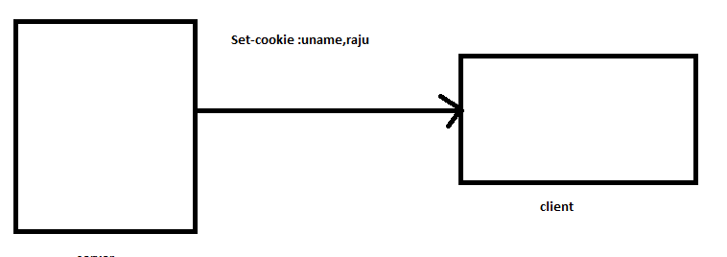
The cookies store in the browser by using domain name of the website.
The browser can store the cookies from different domains also
When the cookies will send to server?
- When the user perform any operation and send the request to server all the cookies from which are belongs to that domain will sent to server.
To send the cookies from client to the server client uses a HeaderCookie

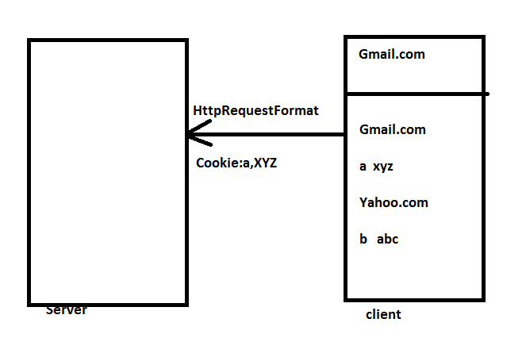
There are two types of cookies are available
- Non-persistant Cookies
- Persistant Cookies
A Non-persistant cookie will be removed when we close the browser.
A Persistant cookie will not be removed even if we close the browser .
Requirement :
Develop a servlet to send cookies from server to the client.
Ex:
public class SendCookie extends HttpServlet{
public void service(HttpServletRequest request,HttpServletResponse response){
Cookie c1 = new Cookie("uname","mys");
Cookie c2 = new Cookie("pwd","abc");
reponse.addCookie(c1);
reponse.addCookie(c2);
}
}
By default we get Non-persistant cookies
The following Jsps send the cookies from server to client.
Ex :
<%
Cookie c1 = new Cookie("uname","mys");
Cookie c2 = new Cookie("pwd","abc");
reponse.addCookie(c1);
reponse.addCookie(c2);
%>
In the jsp’s we observed that an extra Cookie JsessionId is send from server to client.
A server may have any no of resources all the resources of the domain can access the cookies stored in the browser.
Develop a Servlet to receive the cookies Send by the client
If the client having cookies how the cookies will come to server?
When ever the client type any url and click on enter browser creates HttpRequestFormat.browser find all the cookies belongs to that domain and add it to request Header.
Now the request will go to server.server create request and response objects and find the no of cookies available in the requestHeader .and create cookie[] the size of cookie[] based on no of cookies send client to server.
If the client send 3 cookies the size of cookie[] is 3
If the client doesn’t send any cookies cookie[] will hold null value.
Now , the server create cookie object and add it to cookie[].Finally the cookie[] is added top request object.
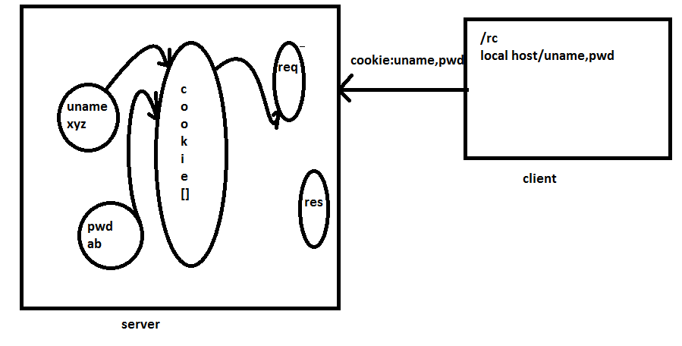
The following ex read the cookies send from client to server.
Ex :
public class SendCookie extends HttpServlet{
public void service(HttpServletRequest request,HttpServletResponse response){
Cookie c[] = request.getCookie();
PrintWriter out = response.getWriter();
response.setContentType("text/html");
if(c !=null){
out.println("Cookie c[]:"+c+"<br>");
out.println("Cookie c[]:"+c.length+"<br>");
for(int i=0;i<c.length; i++){
Cookie rc =c[i];
out.println(rc.getName+"<br>");
out.println(rc.getValue+"<br>");
}
}
else{
out.println("cookies are not available");
}
}
}
When we are developing the programto receive th cookies it is mandatory that we need to check the condition whether cookies[] is null or not.
We can use same above code in jsp’s.
Develop a jsp to receive a specific cookie and its value and use its value in future.
To read the values of specific cookies we must declare a LocalVariables and store the values in to Local variables and use it any where.
Ex :
<%
String a =null;
String x= null;
Cookie[] = request.getCookies();
if(c != null){
for(int i=0;i<c.length; i++){
Cookie rc =c[i];
if(rc.getName().equals("a")){
a= rc.getValue();
}
if(rc.getName().equals("x")){
x= rc.getValue();
}
}
}else{
out.println("cookie are not available");
}
%>
<br>
<%=a%><br>
<%=x%>
A cookie will have additional attributes such as comment,path,domain qualifiers and max age.
All this attributes are not supported by all the browsers.According to cookies specification it is not recommendd to use additional cookies.
A browser can accept 20 cookies per domain and a browser can accept maximum of 300 cookies.
A cookie can hold max of 4 kb data.
Ex:
Step 1: Student.html
Step 2: parents .jsp
<%
String sno=request.getParameter("sno");
String Name=request.getParameter("Name");
Cookie c1 = new Cookie("sno",sno);
Cookie c2 = new Cookie("Name",Name);
reponse.addCookie(c1);
reponse.addCookie(c2);
%>
< form action="/webapp/address.jsp">
fname<input type ="text" name="fname"/><br>
mname<input type ="text" name="mname"/><br>
<input type ="submit" value="Next"/><br>
</form>
Step 3:
Develop address.jsp
Ex :
<%
String sno = null;
String Name=null;
String fName=request.getParameter("fName");
String mName=request.getParameter("mName");
Cookie[] = request.getCookies();
for(int i=0;i<c.length; i++){
Cookie rc =c[i];
if(rc.getName().equals("Sno")){
a= rc.getValue();
}
if(rc.getName().equals("Name")){
x= rc.getValue();
}
}
Cookie c1= new Cookie("Sno",Sno);
Cookie c2 = new Cookie("Name",Name);
Cookie c3 = new Cookie("fName",fName);
Cookie c4 = new Cookie("mName",mName);
reponse.addCookie(c1);
reponse.addCookie(c2);
reponse.addCookie(c3);
reponse.addCookie(c4);
%>
<form action="/webapp/store.jsp">
street<input type ="text" name="street"/><br>
city<input type ="text" name="city"/><br>
<input type ="submit" value="Next"/><br>
</form>
Step 4: Develop Store.jsp
<%
String sno = null;
String Name=null;
String fName=null;
String mName=null;
String fName=request.getParameter("fName");
String mName=request.getParameter("mName");
Cookie[] = request.getCookies();
for(int i=0;i<c.length; i++){
Cookie rc =c[i];
if(rc.getName().equals("Sno")){
Sno= rc.getValue();
}
if(rc.getName().equals("Name")){
Name= rc.getValue();
}
if(rc.getName().equals("fName")){
fName= rc.getValue();
}
if(rc.getName().equals("mName")){
mName= rc.getValue();
}
}
%>
The following details are stored in DB
<%=Sno%><br>
<%=Name%>
<%=fName%>
<%=mName%>
<%=Street%>
<%=City%>
If already cookies are available in the client and if the server sending cookie with the same name and different value browser will override the value with new value.
In every we have options to disable the cookies.we have disable the cookiesand trying access the applications like Gmail.It display an error msg plz turn on cookies?.
If the program send the cookies to the client any program which is belongs to that domain can access the cookies.
The following are the drawback of cookies
1)If the client does’t accept the cookies application wii not work
2)because of security reason it is not recommended to use cookies
3)huge amount data can transfer between client and server.
By default we obserbed that cookies are removed when ever we close the browser.we would like to develop a cookie which will be available in the browser memory ever if we close the browser and start it.
To make the cookie as persistant we specify MaxAge.
Ex :
<%
Cookie c = new Cookie(“uname”,”raju”);
c.setMaxAge(100);
response.addCookie(c);
%>
When we use Non-persistant cookies they get stroed in browser memory.when we close the browser the Non-persistant cookie will be removed.this is becoz memeory de allocated
When we make a cookie as a persistant the cookie information will be stored in files related to the browser.
Session
Session is an object .This object is created by the server.The meaning of creating session object is creating the object to a class which provides the implementation of javax.servlet.http.httpSession.
When ever client has send the request to the server for the firstTime server creats a session object on behalf of the client.
Now,the server call a unique alagorithm to generate a unique id.This id is associated with session object.
Now,the server creates a cookie whose name is JsessionId with unique id as the value and send the cookie to the client.
To request the server to create the sessionObject we can use two methods. They are
HttpSession getSession(true);
HttpSession getSession(false);
The following is an example of creating session Object.
Ex :
public class SendCookie extends HttpServlet{
public void service(HttpServletRequest request,HttpServletResponse response){
PrintWriter out =response.getWriter();
HttpSession session =request.getSession(true);
out.println("session:"+session.getClass());
out.println("session:"+session.getId());
out.println("session:"+session.isNew());
}
}
When ever server has executed request.getSession(true) it check on behalf of client the session object is already available (or) not. It creates a new session object and return the address.
If the client object is already available request.getSession(true) returns available of session object.
When ever the server has encountered request.getSession(false) on behalf of the client of the session object is not available sever will not create a new SessionObject.it returns a null value.
Session is implicit variable in jsp’s.when ever we send the request to sever immeadiatly session object will be created .
Jsp’s internally uses request.getSession(true);
Ex :
<%
out.println("session:"+session.getClass());
out.println("session:"+session.getId());
out.println("session:"+session.isNew());
%>
If I want to use request.getSession(false) in jsp’s we cannot achieve it directly.this is because session is an implicit variable will always get request.getSession(true) .
To achieve request.getsession(false) we need to ask the jsp compiler not to create implicit variable.
This can be achieved by using session page directive
Ex :
<%@ page session=”false” %>
<%
HttpSession session = request.getSession(false);
out.println("session:"+session.getClass());
out.println("session:"+session.getId());
out.println("session:"+session.isNew());
%>
We can use session objects to store the data.As part of session object we store browser specific data.
Sessions objects are ment to store the specific data.
We can store any object in to session objct.we use the following 3 method s to perform operation with sessions object.
Void setAttribute(key,object);
Object getAttribute(key)
Void removeAttribute(key)
Ex :
public class SendCookie extends HttpServlet{
public void service(HttpServletRequest request,HttpServletResponse){
response.setContentType("text/html");
HttpSession session = request.getSession(true);
String name ="raju";
PrintWriter out = response.getWriter();
session.setAttribute("uname",name)
Object o = session.getAttribute("uname");
String s = (String) o;
out.println(s+"<br>");
session.removeAttribute("uname");
out.println(session.getAttribute("uname")+"<br>");
}
}
If we don’t know the key names we can get the key name by using a method getAttributeNames()
Ex :
<%@page import ="java.util.*"%>
<%
session.setAttribute("uname","mys");
session.setAttribute("pwd","xyz");

Enumeration e = session.getAttributeNames();
while(e.hasMoreElements()){
out.println(e.nextElement());
}
%>
Develop multiple form based application by using sessions.
Step 1: Develop student.html
Step 2:Develop parents.jsp
In this capture data from Student.html and store it in the session object and display the form.
<%
String sno=request.getParameter("sno");
String name=request.getParameter("name");
session.setAttribute("sno",sno);
session.setAttribute("name",name);
%>
<form action="/Session/address.jsp">
FatherName:<input type="text" name="fname"/><br>
MotherName:<input type="text" name="mname"/><br>
<input type="submit" value="Next"/>
</form>
Step 3:
Develop address.jsp
<%
String fname=request.getParameter("fname");
String mname=request.getParameter("mname");
session.setAttribute("fname",fname);
session.setAttribute("mname",mname);
%>
<form action="/Session/store.jsp">
Street:<input type="text" name="street"/><br>
City:<input type="text" name="city"/><br>
<input type="submit" value="Store"/>
</form>
Step 4:
Develop Store.jsp
<%
String sno=(String)session.getAttribute("sno");
String name=(String)session.getAttribute("name");
String fname=(String)session.getAttribute("fname");
String mname=(String)session.getAttribute("mname");
String street=request.getParameter("street");
String city=request.getParameter("city");
%>
The following details are stored..<br>
<%=sno%><br>
<%=name%><br>
<%=fname%><br>
<%=mname%><br>
<%=street%><br>
<%=city%><br>
<a href="/multi/student.html">Again......</a>
When we test the above project by disabling the cookies application is not working.
Note :
Sessions also is having a problem if the client disable the cookies.
Requirement :
Implement a project to get the username and pwd to the user and display the appropriate Login Screens .If the user trying to access any program unauthorizedly display an error message plz log in first.
1)When to store the data into request Object?
The data which is specific to that request then we store in request Object.
2)When to Store Data in SessionObject?
The data which is specific to browser/client then that can be stored in Session Object.
3)When to store data in to application?
The data which can be accessible any clint any request we can store it in application Scope.
When ever client open browser and send the request to the server on behalf of client server will create a session Object.server has sent a JsessionId to the client.Now,the client has to closed the browser. As the client closed the browser server will not remove session object.if the user repeate this process so many session objects are created in the server and they are not removed because of this reason we end up with lot of memory related problems.
To remove the session object we use a method invalidate().
Session.invalidate();
When ever we call invalidate() method server will mark the object has invalid.it is responsibility of the garbage Collector to to remove all unused session Objects.
When ever we call invalidate() the data associated to session object also get Removed.
If the server has marked the session object invalidate and the client sends the JsessionId to server .Server checks whether object is in use or not .server create a new session Object.
Scenario 1:
Generally we call invalidate() method as part of logout functionality
----------------------→change time in tomcat config←-----------------
Scenario 2:
It is responsibility of the server to remove the session object if it is not used for certain amount of time server uses a method getLastAccessedTime() to check when the session object is used.if it is not used for certain amount of time server removes Session Object.
It is not recommended to change the server session time out.this is because it will effectd to all the projects which are available in server.
Different projects uses different session time out.
Scenario 3:
Specify the session time out to a project we can achieve this by configuring it in web.xml
We use the following tags to configured session time out in projects.
Ex :
<web-app>
<session-config>
<session-timeout>1</ session-timeout>
</session-config>
</web-app>
Scenario 4:
We can use a method setMaxInactiveInterval();
We use the above method to specify the time out to the session objects created by the program.
Ex :
HttpSession session = request.getSession(true);
Session.setMaxInactiveInterval(120);
When the above code is executed the server removes the session object if it is not used for 120 secs.
Server remove the session object according to the following sequence.
1)Program level.
2)project level.
3)server level.
EncodeURL :
When we use this encodeUrl if the client doesn’t accept the cookies when ever encodeUrl is called what ever URL we are supplied will be appended with ths JsessionId of the sessionObject and it will be sent to the client.
/webapp/parents.jsp?JsessionId=value
EncodeUrl method will find whether the clint accepts the cookies or notif the clinet accept the cookies encodeUrl does’t modifie the url which we supplied.
Ex:
<form action=<%=response.encodeURL(“/webapp/address.jsp”)%>
</form>
ScopedVariables :
scoped variables are used to store the data.there are 4 scoped variables are available.
They are 1)page Scope
2)requestScope
3)SessionScope
4)applicationScope

1)PageScope :
Storing the data into page context Object is called as PageScope.if we store the data into pageScope it will be available until _JspService() is executed.
Ex :
<%
String name= "raju";
PageContext.setAttribute("uname",name);
String s = (String)PageContext.getAttribute("uname");
out.println(s);
out.println(pageContext.removeAttribute("uname"));
%>
2)requestScope :
Storing the data into request Object is called as requestScope.
When to use requestScope?
In a single request we want to execute more than one servlet and they would like to share the data in this scenario we use requestScope.
3)SessionScope :
Storing the data into session Object is called as Session Scope.
When to store the data into session object?
From a single browser we would like to send multiple requests to execute multiple programs.if they want to share the data we use sessionscope.
4)ApplicationScope :
Storing the data into servletConetxt objext is called as applicationScope.
If we want to store the data into application scope every browser every clent can access it.

RequestDispatchers :
RequestDispatcher is an object which is used to dispatch the request from one resourse to another resource.
By using requestDispatchers in a single request we can execute multiple servlets.
RequestDispatcher is an interface available in Javax.servlet package.
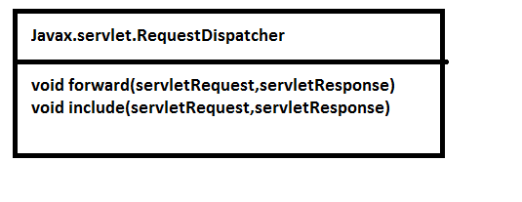
There are two ways are available to request the server to get requestDispatcher servlet object
They are
1)application.getRequestDispatcher(path)
2)request.getRequestDispatcher(path)
Application.getRequestDispatcher expect us to supply only absolute path. where as request.getRequestDispatcher we can supply both absolute path and relative path.
http://localhost:8000/webapp/xxx/fs
webapp/xxx/fs webapp /xxx/fs
url contextPath path
always absolute path starts from with / .relative path will not start with / to find the relative path you should always know about absolute path
Ex First Servlet
import javax.servlet.http.*;
import java.io.*;
import javax.servlet.*;
public class FirstServlet extends HttpServlet{
public void service(HttpServletRequest request,HttpServletResponse response) throws IOException,ServletException{
PrintWriter out =response.getWriter();
out.println("we are in First servlet");
ServletContext application=getServletContext();
RequestDispatcher rd=application.getRequestDispatcher("/xxx/yyy/ss");
rd.include(request,response);
}
}
SecondServlet
import javax.servlet.http.*;
import java.io.*;
import javax.servlet.*;
public class SecondServlet extends HttpServlet{
public void service(HttpServletRequest request,HttpServletResponse response) throws IOException,ServletException{
PrintWriter out =response.getWriter();
out.println("we are insecond servlet");
}
}
When ever the client send the request to the above first servelet server has created o request and response objects these objcts are hand over to its firstServlet service service ().when ever requestDispatcher object is encountered server create servlet object and call the service method by supplying the same request and response object.after the second servlet is executed the include() clubbed o/p of firstServlet and secondservlet and send output to the client.
FirstServlet is called as calling Servlet and second servlet is called as calledServlet.

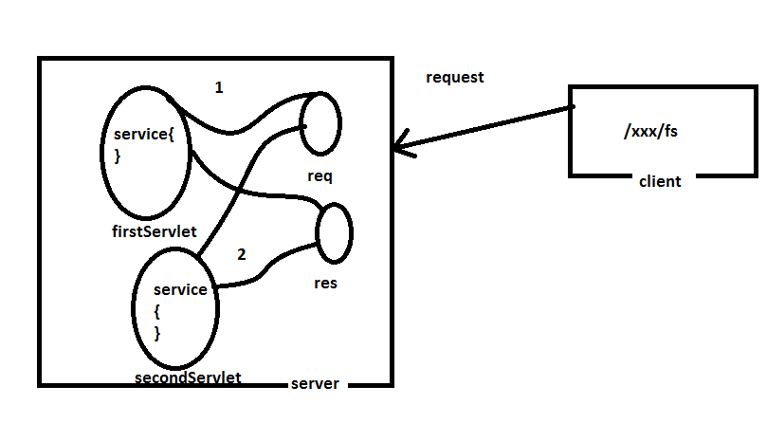
When ever we call rd.forward() RequestDispatcher execute 2nd servlet.The forward() will discard the output of the firstServlet and consider the output of called servlet.
What is ServletChaining?
Processing more than one servlet in a single Request is called as ServletChaining. we can achive the servlet chaining by using requestDispatchers.
From one servlet we can call/use multiple include methods. From one servlet we cannot use multiple forwards it will throw an illegalState Exception.
We can use RequestDispatchers directly in jsp scriptlets.
Eg:
<%
RequestDispatcher rd = application.getRequestDispatcher(“/two.jsp”);
Rd.include(request,response)
%>
As it is not recommended to write java code in jsp’s.SunMicrosystem given has 5 action tags.
- Include
- Forward
- useBean
- setProperty
- getproperty
Include :
<jsp:include attribute=””/>
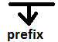
When ever we use include action tag it is responsibility od the jsp compiler to evaluate the tags. The meaning of evaluating tag is converting tag in to corresponding java code.
When the jsp compiler evaluates the tag it checks whether all the required attributes are provided (or) not. If not available jsp compiler throws an exception .
Eg:
From one.jsp
<jsp:include page=”/two.jsp”/>
Include action is called as DynamicInclude.because every time when the client send the request to the server it execute multiple servlets and clud output and send it to the client.
2)Forward
Forward action is used to forward the request the jsp with out we writing java code
From one.jsp
<jsp:forward page=”/two.jsp”/>
IncludeDirective
includeDirective is also used to include the output of multiple resourses and send the output to the client.
From one.jsp
< %@jsp:include page=”/two.jsp”/>
Include directive is calld as static include.
When we use the include directive it will club two different jsp’s to a temperory jsp.this temperory jsp contain contents of callingJsp and calledJsp.Now, the server creates only one servlet every time client sends the request only one program send the output.
Because of this reason we will this Directive as StaticInclude.
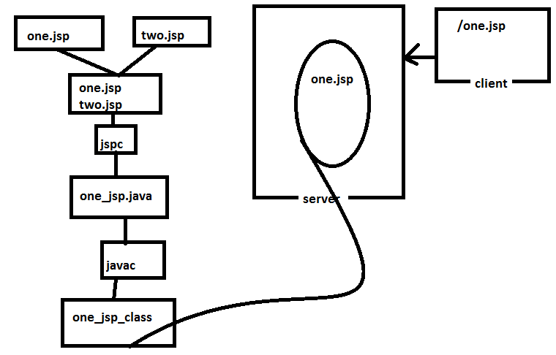
When ever we call application.getRequestDispacher() internally it will find the context path of the project and appending with the path supplied by the user.if path does’t start with ‘/’ it throws an exception.
After the getRequestDispacher() is executed successfully the requestDispatcher object holds the URI of the another resourse.Now , the server starts behaving like a new request and project.
When ever we call request.getRequestDispacher() internally it will find the context path of the project and appending with the path supplied by the user.if path does’t start
with ‘/ ‘ it will find the path of the current servlet and append to it.
getNamedDispatcher
NamedDispatchers are used to dispatch the request based on name of the servlet configured in WEB.XML
import javax.servlet.http.*;
import java.io.*;
import javax.servlet.*;
public class FirstServlet extends HttpServlet{
public void service(HttpServletRequest request,HttpServletResponse response) throws IOException,ServletException{
PrintWriter out =response.getWriter();
out.println("we are in First servlet");
ServletContext application=getServletContext();
RequestDispatcher rd=application.getNamedDispatcher("mys");
rd.include(request,response);
}
}
Scenario 1:
We can use requestDispatchers to dispatch request from fisrtServlet to second Servlet if they are available in same server ,same project.
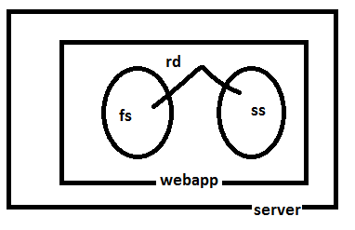
Scenario 2:
We can use requestDispatchers to dispatch request from fisrtServlet to second Servlet if they are available in two different projects ,same server.
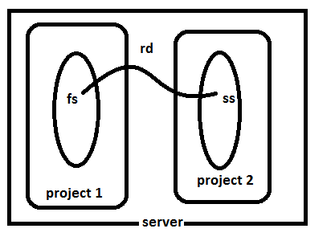
Scenario 3:
We can use requestDispatchers to dispatch request from fisrtServlet to second Servlet if they are available in two different servers.
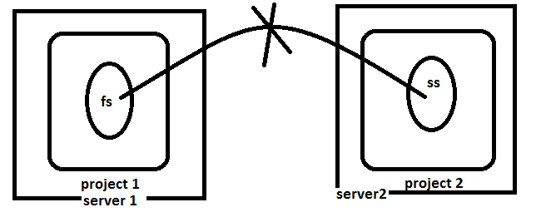
SendRedirect :
To use sendRedirect we use a method response.sendRedirect();
<%
Response.sendRedirect(“two.jsp”);
%>
<%
Response.sendRedirect(“www.oracle.com”);
%>
When ever server has encounterd sendRedirect it will stop executing program and send the temporary response to the client.
When ever client achieves a temporary response it takes the values of Location.header and send another request to server.
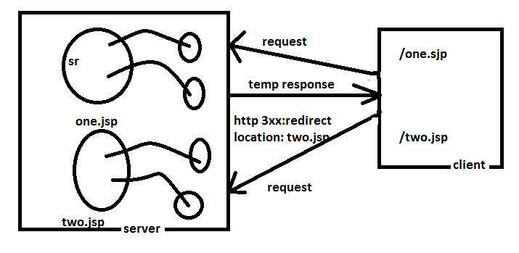
Jsp Action Tags
4) UseBean :
UseBean tag is used to create an object to any javabean.
<jsp:useBean id=”e” class=”info.inetsolv.Emp” scope=”page”/>
${e}
When the above action tag is evaluated it create Emp object and store it the scope attribute can take care of values Scope,request,session and application.
If we does’t specify scope attribute by default it uses pageScope.
When the useBean is evaluated it checks with given id is there any key available in the scope or not. If it is already available it will not create the object.
SetProperty
setProperty is used to call the setterMetrhods
<jsp:setProperty name=”a” property=”eno” value=”10”/>
getProperty
getProperty is used to get the value and display the output to the client
<jsp:getProperty name=”a” property=”eno”/>

